**Apache Spark Fundamentals**

**What is Spark?**

* Open source, distributed processing system
* utilizes in-memory caching and optimized query execution for fast queries against data of any size
* Faster than previous approaches to precess Big data, like MapReduce
* Processing runs on memory (Not in disk drives)
* used for multiple things like
  + running distributed SQL,
  + creating data pipelines,
  + running Machine Learning algorithms,
  + working with graphs or data streams
* Spark is deployed on the top of Hadoop Distributed File System (HDFS)

Spark components

* Spark core - general execution engine
  + Provides: in-memory computing, referencing datasets in external drives
* Spark SQL - Spark module for working with structured data.
* Spark Streaming - Process real time streaming data.
  + Data can be ingested from many sources like Kafka, Flume, and HDFS
* MLib - a rich machine learning library
  + ML Algorithms - classification, clustering, regression, collaborative filtering
* GraphX - manipulate graph databases and perform graph executions
  + Graph -> ETL ( Extract, Transform, Load)

Why Spark?

In-memory processing

Real time processing

Flexibility

Better Analysis

Spark Use

State-of-art DAG scheduler

Query optimizer

Physical execution engine

Spark allows up to perform same hadoop computation, to fractions of data/ clusters faster in-memory.

**Issues when processing big data in a single machine**

Resources are limited

Algorithm complexities

Disk bottleneck

*Spark: generalizing/ providing abstraction to hadoop HDFS and its different libraries to simplify code/ workload.

* Bringing all different libraries to one stack/ platform.

So it’s called → Unified platform for big data

Spark support generality:

Makes it easy to combine different processing models seamlessly in same application.

**Getting started with Spark project with InteliJ IDEA**

*Spark project is managed by Gradle

*Gradle has an IDEA plugin which can generate all the necessary

files that are required by InteliJ

Plugin will register a gradle task, called idea

We use gradle wrapper (gradelw) to download and configure all

necessary files for the spark local setup.

Scala-Spark Project Structure

Source code available in: src/main/scala/package_name

Categorized into 4 categories:

* Advanced
* Commons
* pairRdd
* Rdd
* sparkSql

All input data sources are kept inside:

* In

**What is RDD?**

* Resilient Distributed Datasets (RDD) is a fundamental data structure of Spark.
* It is an immutable distributed collection of objects.
* Each dataset in RDD is divided into logical partitions, which may be computed on different nodes of the cluster.
* RDDs can contain any type of Python, Java, or Scala objects, including user-defined classes.
* RDD is a read-only, partitioned collection of records.
* There are two ways to create RDDs
  + **parallelizing** an existing collection in your driver program,
  + **referencing a dataset** in an external storage system, such as a shared file system, HDFS, HBase,

Spark RDD will store intermediate results in a distributed memory instead of Stable storage (Disk) and make the system faster.

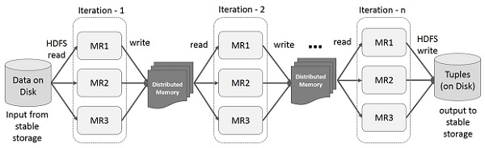

Interactive Operations (Querying) - If different queries are run on the same set of data repeatedly, this particular data can be kept in memory for better execution times

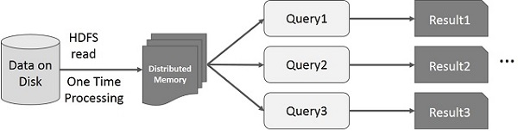

**Spark code structure**

conf = sparkConf() <-- Spark Configurations

.setAppName(‘app_name’) <-- Setting a name for the Spark app

.setMaster(‘local[3]’) <-- Processing machine (currently local

machine) and no CPU cores used.

sc = new SparkContext(conf) <-- create spark instance/ main entry point

sc.textFile(“file”); <-- Read the text file

**RDD Basics**

RDD is the spark’s core abstraction in working with Data.

What is a dataset?

Collocation of data

Ex: list of strings, numbers ,data from a relational database etc.

RDD can contain any type of objects, including user-defined classes.

RDD : simply a capsulation around a very large dataset, In Spark all work is expressed as either creating new RDDs, transforming existing RDDs , or calling operations on RDD to compute a result.

**RDD Operations**

1. **Transformations**
2. **Actions**

Transformations: applying some functions to the data in a RDD to create new RDDs.

Ex: *filter and map*

Will return a new RDD with a subset of original RDD Data.



Actions: Compute a result based on RDD

Ex: *first*

Will return the first element in the RDD

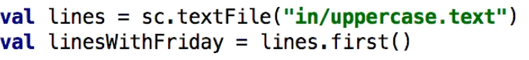

**General Spark RDD Workflow:**

1. Generate initial RDDs from external Data
2. Apply necessary transformations. Ex: filter
3. Launch actions. Ex: count

**Creating RDDs**

SparkContext’s **parallalize** method :

All the elements in a given collection to this method, will be copied to form a distributed dataset that can be operated in **parallel**.



* This is the simplest way to to create a RDD.
* Not practical in Real Life scenarios. As it requires entire dataset to be imported.

sc.textFile() : load RDDs from a external file.

* The external storage we require to import will be a distributed file system, like Amazon S3 or HDFS.

**filter() transformation**

Takes in a function and returns an RDD formed by selecting only a set of elements which pass a given filter function.

Usecase:

Can be used to remove some invalid rows

Get a subset of a given RDD based on a filter



**map() transformation**

Takes an input RDD, process each elements through a function and assigning new value to each element after operation and results a new formed RDD.

* Map() transformation is a versatile.

Usecase:

Can be used to make HTTP requests to each URL in an input RDD,

Calculating the square root of each given set of numbers



* Return type of the RDD is not necessarily required to be same as the resulting RDD.

Note: No of output files created after transformation operation = no of CP Cores allocated (No of worker threads)

flatMap transformation



A function is applied on each element in RDD and then flatting the results.

Usecase:

Split words from a given string and flaatten them into a list of words.

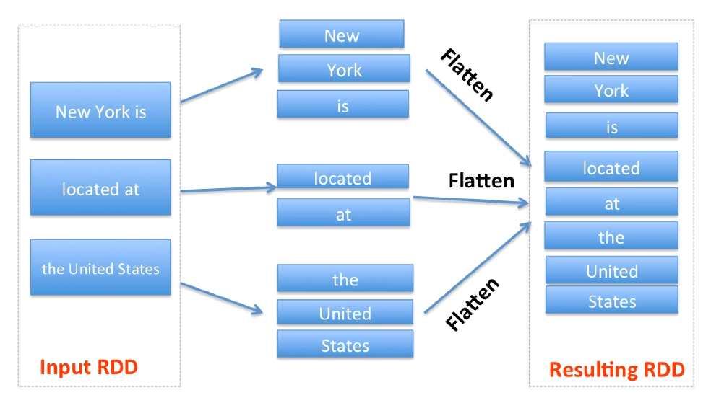

Map vs FlatMap

Map: Used in 1-to-1 relationships

FlatMap: Used in 1-to-many relationships

What is this code snippet?



When a scala code is executing, all the loggers are logged from Spark package. So It’s noisy and not easy to find expected outputs. Therefore here we are setting the logging level to “ERROR” only.

Sparks libraries are coming from “org” package.

flatMap() example:

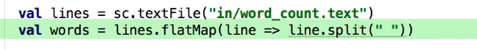

This will split words from each row and flatten all the results into one single List.

**Set Operations**

-sample -distinct (This operation are performed on one RDD)

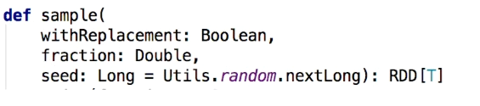

***Sample*** will create a random sample of elements as a new RDD from a given RDD.

Useful for testing purposes.

**\*withReplacement:** whether an element can be included in multiple times in the sample.

**\*fraction:** expected sample as the fraction of this input RDD.

With replacement: fraction = 0 to 1

Without replacement: fraction = equal to or greater than 0

**\*seed:** seed for the random number generator.

**distinct()**

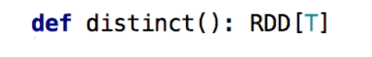

Result a new RDD containing distinct elements of a given RDD.

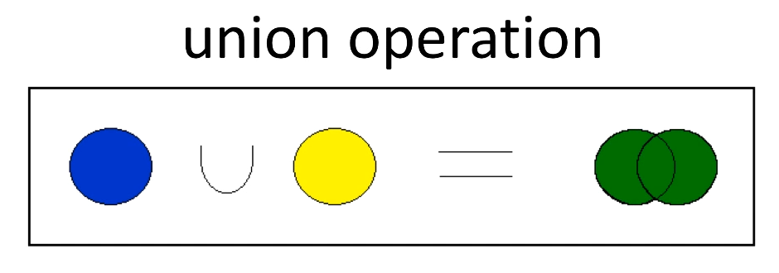

**Set operations performed on 2 RDDs and result in 1 RDD**

* Union
* Intersection
* Subtract
* Cartesian product

**Union** - Given in return a RDD, which consist of all data from both RDDs.

Use Cases:

Aggregate files/ log files from multiple sources

*If duplicates present, there will be duplicates in output RDD as well.

**Intersection** - returns only common elements of a given 2 RDDs.

*this operation also removes duplicate values. (take only distinct)

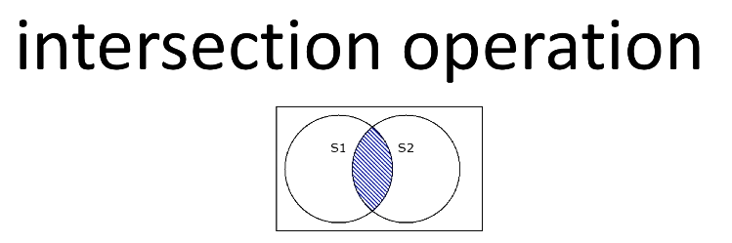

**Subtract Operation:** Return elements only belong to a single RDD, from both RDDs.

This requires sufflig of all the datas. Using on large data sets is quiet expensive (may need more processing power)

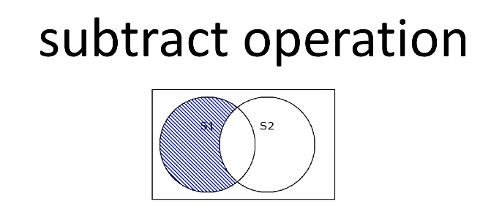

**Cartesian operation:**



Returns all possible pairs of a and b, where a is from one RDD and b is from the other RDD.

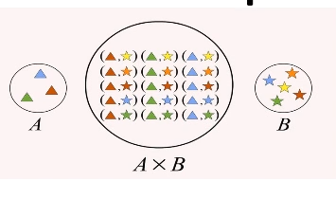

Usecases: compare the similarity between all possible pairs.

Ex: analysing product similarity/ collaborative filtering

*Note:

How to easily filter the header line:

val cleanedHostIntersection = intersection.filter(host => host != "host")

*Assuming header line has the word ‘host’ and no other values does not include that word, therefore we can easily filter it in this way.

**Actions**

Operations which will return a final value to the driver program or persist data to an external storage system.

Common actions in Spark

-collect

-count

-countByValue

-take

-saveAsTextFile

-reduce

**collect() operation**

Retrieves entire RDD and returns it to the driver program in a form of regular collection or value.

Ex: String RDD --> Collect() --> List of Strings

*Note: when the collect action is called, entire dataset need to be fit to the memory on a single machine. (dataset is copied to the memory first)

So collect() action should not be called on large datasets.

Usecases:

Widely used in Unit Tests, to compare the value of RDD, with expected results, (as log as the entire collection in RDD fits in memory)

**How to covert a list of strings into a RDD?**



**For loop to print contents:**

For ( w <-words) println(w)

*this means to pint each element in a new line from *words* list.

Val words = wordRDD.collect()

*converts the RDD into a list of items

**count() and countByValue()**

count() <-- Just to know how many rows in the RDD

countByValue() <-- look for unique values in in each row of RDD nd returns a map of each unique values to its count.

Ex: Value: count

count()



o/p: Count: 7

countByValue()

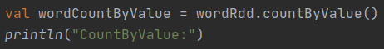

o/p: CountByValue:

Val: count

**take() operation**

Takes n elements from a given RDD

Usecases:

Take only the peak of a RDD/ part of a RDD for unit test or quick debugging.

take() will return a **biased** collection.

And doesn’t necessarily return the elements in the order a expected.

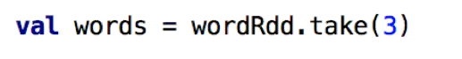

**saveAsaTextFile() operation**

Used to write out data to a distributed system. (ex: HDFS/ Amazon S3)

Or even a local file system.

**reduce() operation**

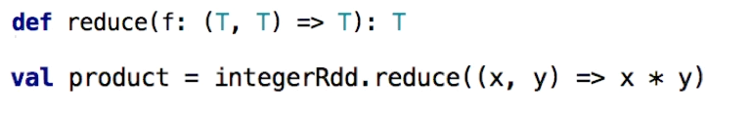

Operates on 2 elements of the type of input RDD, and return a new element in same type.

(reduces the no of elements in the given RDD using a specific binary function)

*Applying this function **repetitively** on same RDD, will result RDD data to be reduced up to a single value.

Usecases:

Used to perform different kind of aggregations.

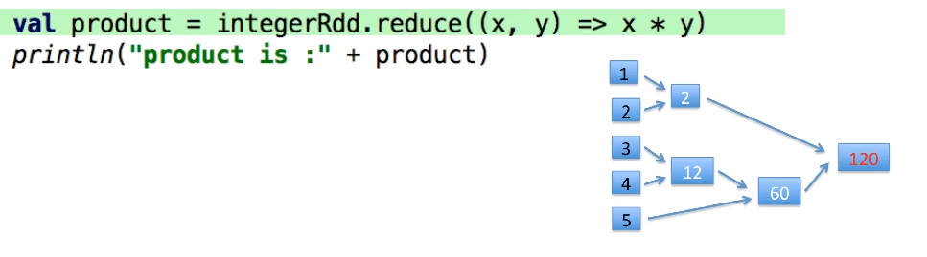

Note: regular expression : **\\s+**  (means one or more whitespaces)

**A best practice to follow ( specially in numerical data handling):**



Check and filter empty values.

**Converting string elements in a RDD to integer.**



**Calling reduce to get the summation**



**Important aspects about RDD**

RDDs are distributed.

Each RDD is broken down to multiple pieces : called partitions.

Partitions are distributed among clusters.

RDDs are immutable

Cannot be changed after they are created.

RDDs are resilient

RDDs are deterministic function of their inputs. RDD parts can be recreated at any time.

In case of any node in the cluster goes down, spark can recovers the parts of the RDD from the inputs and pick up from where it left off.

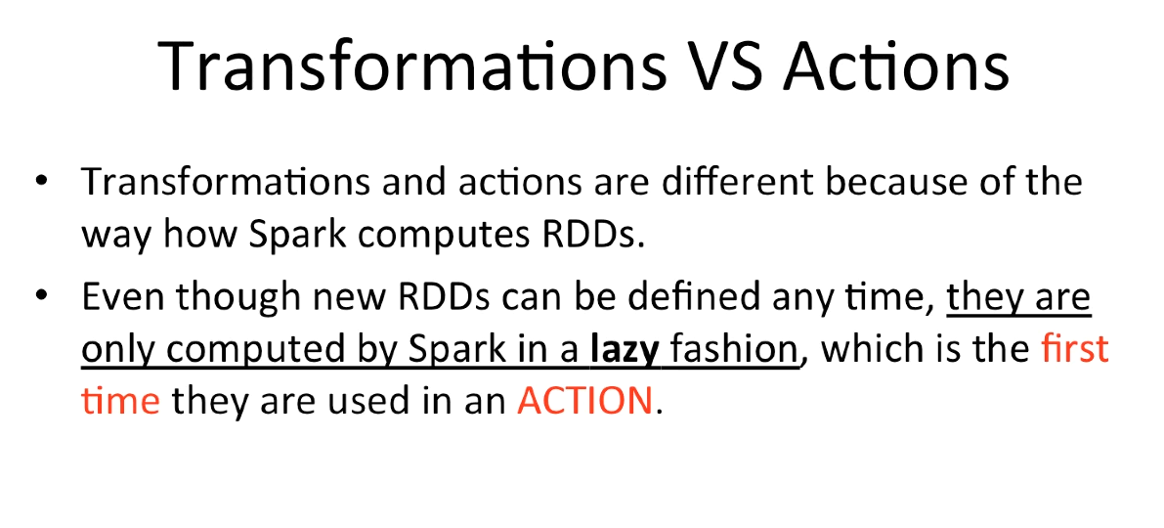

**What is Lazy evaluation?**

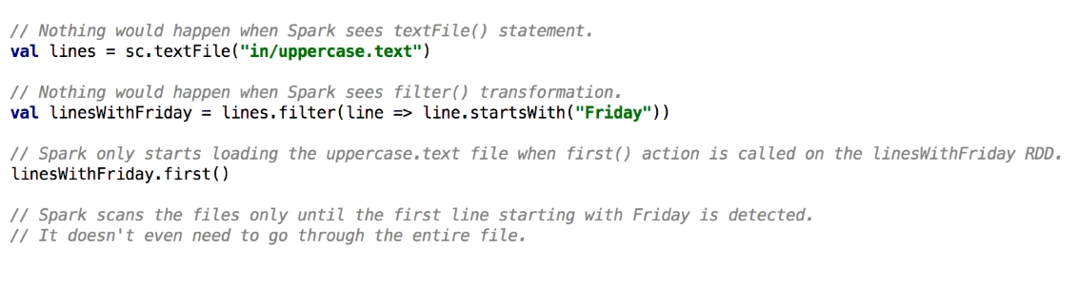

*note: event if we write code to load textFile so on, Spark will perform only the necessary action only if the action is called (event transformations are happened If and only if after an **action** has been called)

Spark is using lazy evaluation to reduces the no of passes it has to take over a set of data, by grouping operations (ex: actions and transformations) together.

**Note:**

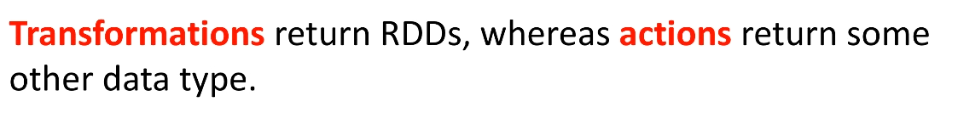

**Caching and Persistence**

Persistence?

Sometimes we may want t call actions on same RDD multiple times.

In such case, RDD and all its dependencies are recomputed each time the actions are performed**.This is very expensive.**

(ex: in some iterative algorithms, calling actions on same data, multiple times)

We can priest transformations, by calling **persist()** method in spark.

If we persist() and RDD, on the first time ii s computed, it will be kept in the memory, to perform upcoming actions.(across the nodes)



*here storage level is limited to : MEMORY_ONLY

**Presistable Storage Levels in Spark**

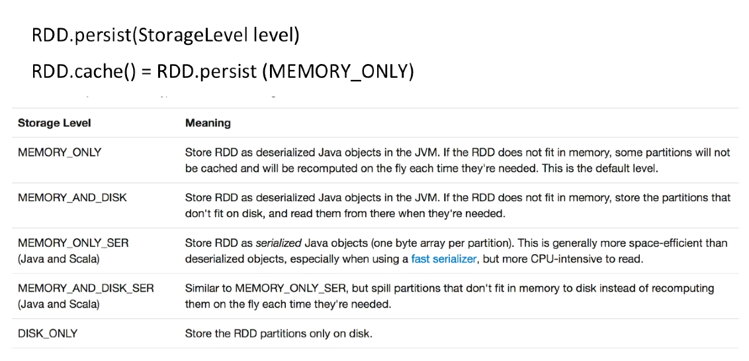

**RDD.cache()**  <--- short form of RDD.persist(MEMORY_ONLY)

Factors to consider before selecting storage levels:

MEMORY_ONLY : Ideal option. Most CPU-efficient option.

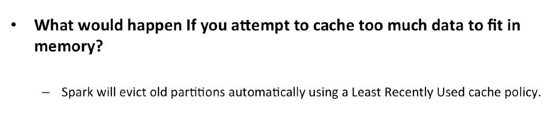

**Spark architecture**

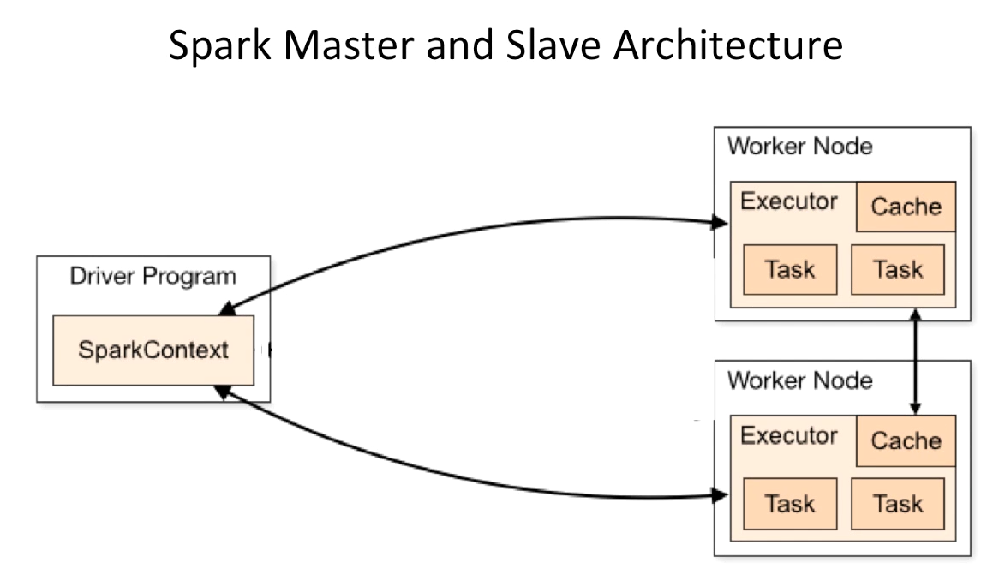

Typical Setup: One master node, a number of slave nodes.(worker nodes)

Drive program: Master Machine

Workers Nodes: Slave machines

Ex: Running a count() operation on a RDD

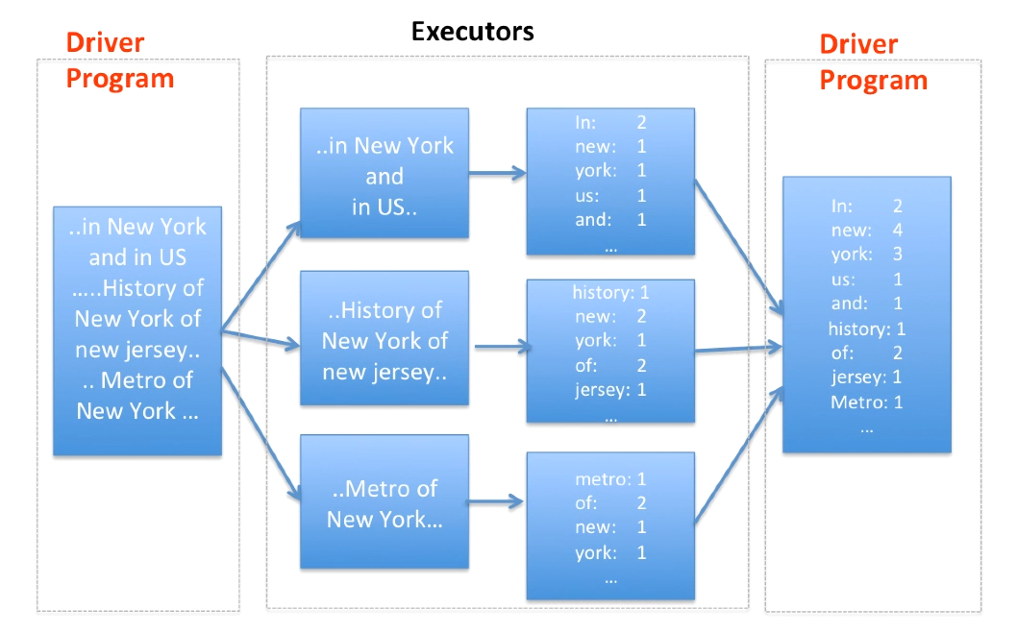

*RDD will be separated into different partitions.

*Partitions will be passed over to different execution workers in nodes in the cluster.

*each executer will perform the action in different ranges of the RDD>

* Driver program will return the result.

**Spark Components:**

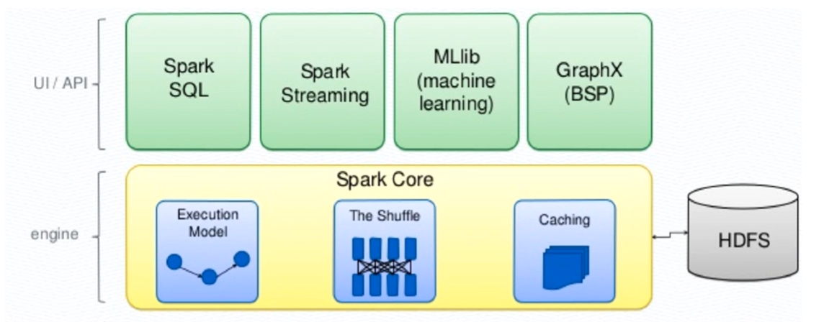

Spark core: Foundation of the overall components.

Provides distributed tasks as batching, performs on a RDD ( which is Spark’s primary programming abstraction)

**Spark SQL -** Spark package designed to working with structured/ relational data.

**Spark Streaming:** When it’s require to process and analyze not only batch data ( as spark usually do) but also **live/ streaming** data.

Streaming provides an API to manipulate streaming data which is closely match with Sparks core RDD.

Enable a powerful analytical approach, across both streaming and historical data.

**MLLib:** Built on Spark. Provide High Quality Machine Learning algorithms.

Library is usable in Java, Python, Scala / as part of Spark applications.

**GraphX:** enables to interactively create, transform, and reason about graph structured data at a scale.

**Use of Spark**

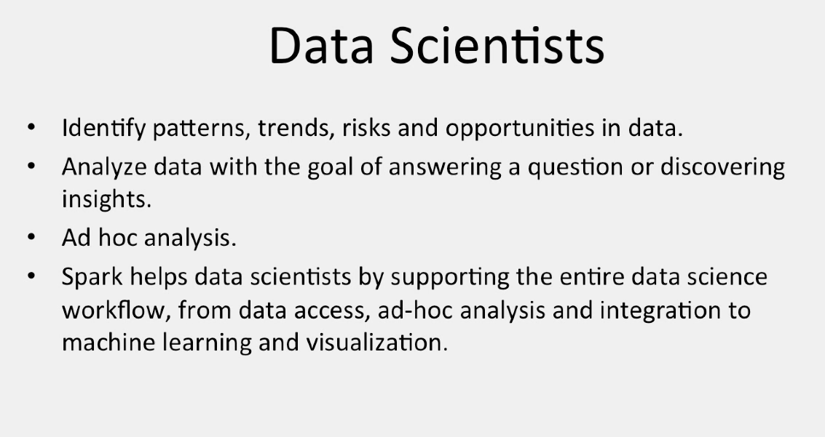

**Pair RDDS**

Thi is required when the dataset in key-value pairs

Key: one value/ or multiple values.

In such cases, Spark provides Pair RDDs , instead of regular RDDs.

**Creating Pair RDDs**

1. Return a pair RDD from a list of key:value pairs (called tuples)
2. Turning a Regular RDD to Pair RDD by Running a Map() function

**Scala Tuples**

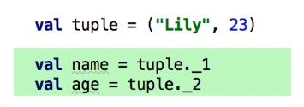

*Elements indexing: starts from 1 | can be accessed with _1 , _2 likewise

**Converting Tuples to Pair RDDs**

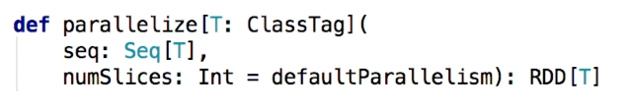

Creating a tuple list and a Pair RDD from it:



**Converting a regular RDD to a pair RDD**

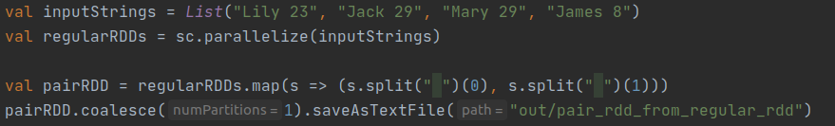

*Split by white spaces, and tuple 2 values as pairs and store in the Pair RDD.

**pairRdd.coalesce(num);**

Spark repartition() and coalesce() are very expensive operations as they shuffle the data across many partitions hence try to minimize repartition as much as possible.

**Transformations on a single Pair RDD:**

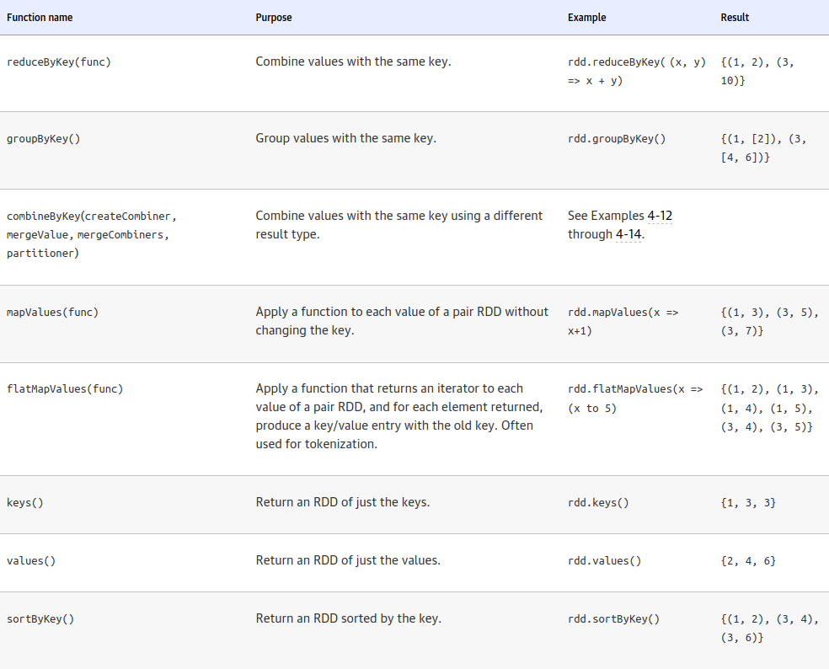

**Applying Transformations on Pair RDDs**

* All transformations can be used, which were used on Regular RDDs.
* As pair RDDs containing tuples, we need to pass functions, which execute on tuples rather than on individual elements.

**filter() Transformations**

Takes a function, and returns a pair RDD, formed by selecting elements only passed through the given function.



*Note: Accessing value of the key:value pair in the piarRDD using _2 index.

Output will be as pairRDD:

(“key”: “value”)

**map() and mapValues() transformation**



mapValues() - this function will get values from each key:value pair in the pairRDD and execute the function on each.

**ReduceByKey() aggregation**

This operation is the same as the reduce() operation in regular RDDs.

If a set of values is having the same ey, will be combined after this operation, as this is run on pairRDD keys.

This operation is not implemented as an action that returns a value to the driver program. Instead it returns a new RDD consisting each key and the reduced value for that key.

Ex: countByValue() operation: this will generate list of processed values as a histogram in memory. But reduceByKey() will not do that, it will complete the processing and finally result the RDD to memory.

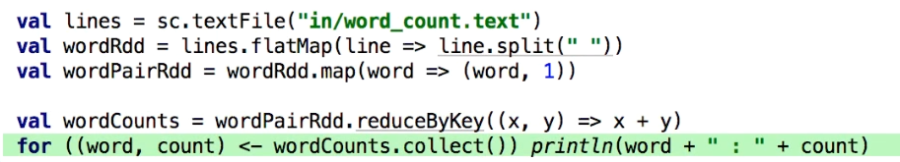

What this code does?

* Fist it will create a pairRDD tuple set with each word against 1. Ex: word:1
* Then with the reduceByKey operation, it will get the summation of all values of the same key. And result **word:word count** like key: value pair.

**wordCount.collect()**

This method will return the processed pairRDD to the driver program as a map. (AS reduceByKey does not return map o the driver program)

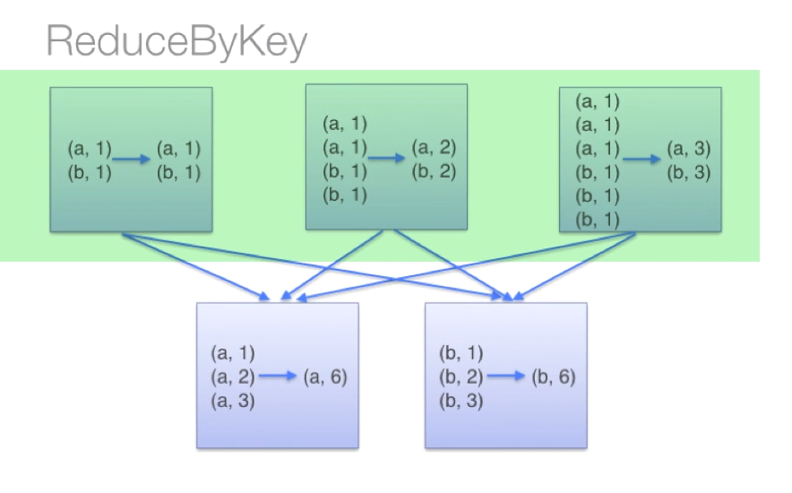

**groupByKey() transformation**

A common use case of pair RDDs.

Ex: viewing all account transactions together.

Note: If our data is already keyed in the way we want, this operation will group our data using the key in our pair RDD.

Note:

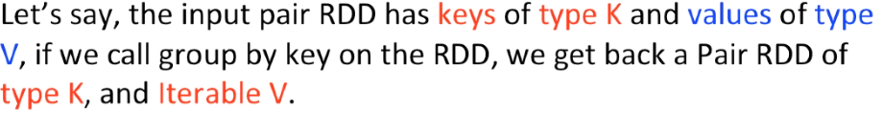

Ex:



**groupByKey() vs. reduceByKey()**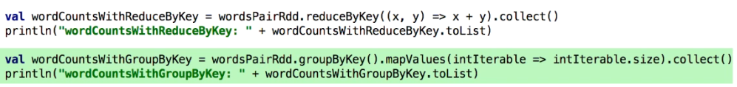

Fisr code snippet represents how to get the word counts using reduceByKey() transformation.

2nd Approach groups the values of wordsPairRDD by key and the mapValues with size of each iterables ( How may steps will take if iterated, simple no of occurrences of the key: or the word)

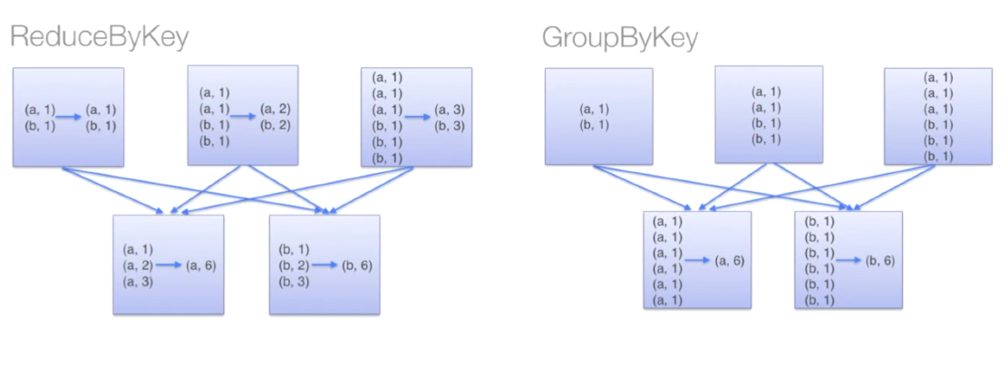

Note: In reducedByKey() : similar data (same key) is combined together before shuffling or reduced.

Note: when groupByKey() is called all the key:value pairs are shuffled, finally will be grouped. So this is a performance wise expensive task to perform.

**sortByKey() Transformation**

Usecases: When producing a downstream output.

Once an RDD is sorted, any future actions, or transformation will return the RDD data in the sorted order.

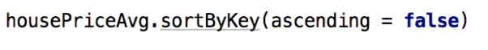

Ascending - false (sort in reverse order)

When the field which need to be sorted, presented as values in the pair RDD, we need to flip and apply sortByKey()

Ex:

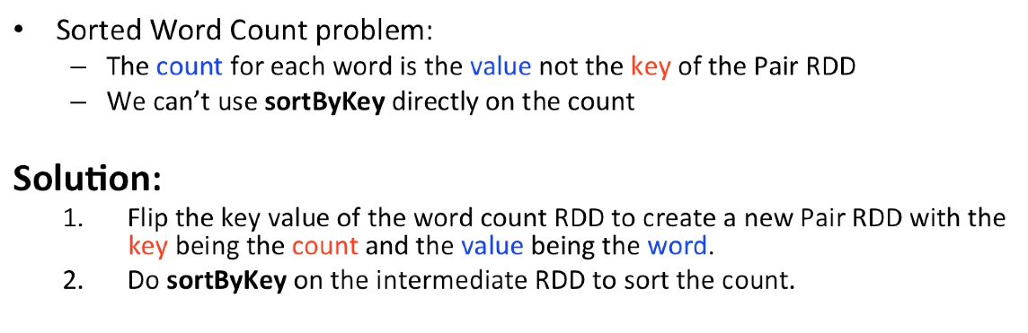

Flipping, sorting and flipping again:

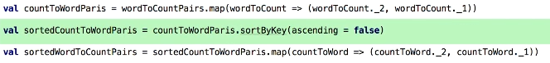

**Data Partitioning**

groupByKey() is an expensive action to perform.

So before such action executes, we can partition data.



In this way partitionBy() is called first, and then no matter how many time groupByKey() is called, as data won’t shuffle again and again.

Operations which would benefit from partitioning:

Join

leftOuterJoin

rightOuterJoin

groupByKey

reduceByKey

combineByKey

lookup

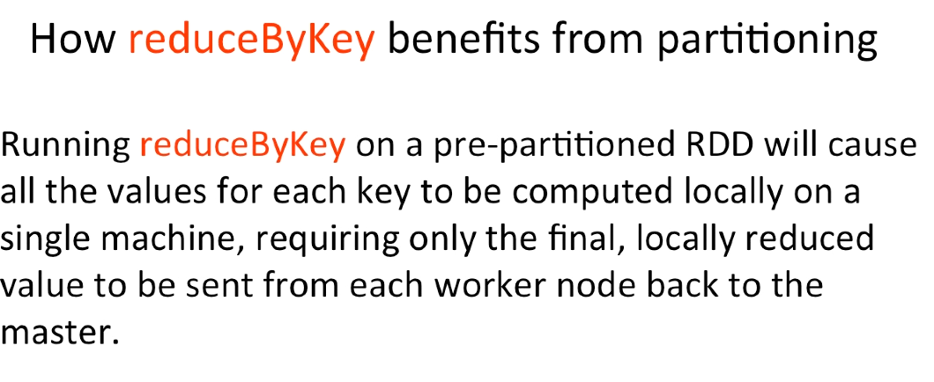

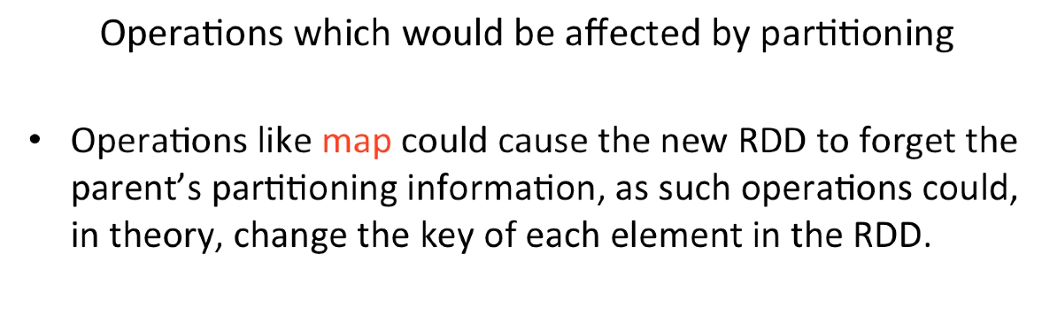

**Join Operations**

Allow to Jin two RDDs together.

Join Types: leftOuterJoin

rightOuterJoin

crossJoin

innerJoin

**Inner Join**

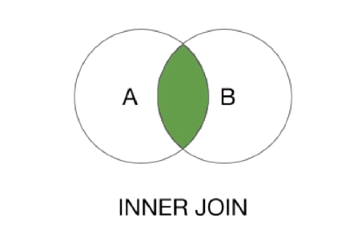

In one input RDD, multiple values has same key,

Resulting Pair RDD will have an entry for every possible pair of values, with that key from the two input RDDs.

This approach omits the Key.

If suh cases, we want to the key to be also present,

Use **Outer Joins.**

**Outer Joins**

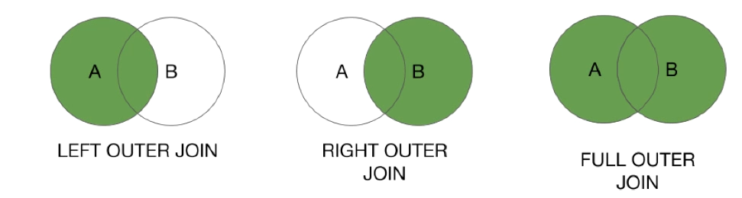

* Resulting RDDs has entries for each key in the source RDDs.

Understanding Joins:

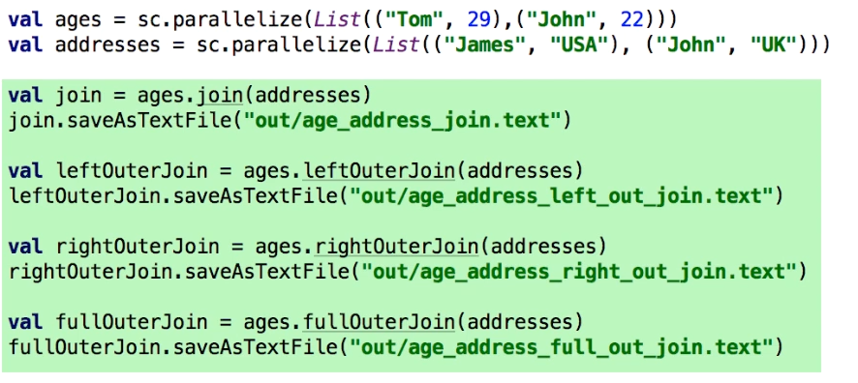

*Note: Here both ages and addresses has “Jhon” as the key.

Inner Join:

(Jhon(22,UK))

Only One Result Reason: Only “Jhon” is in both..

Left Outer Join:

Tom,John

Reson: They both are present in the ages (left) RDD

Right Outer Join:

James, Jhon

Reson: They both are present in the addresses (right) RDD

Full out Join:

All possible key:value pairs are included.

**Accumulators**

* Variables that are used to aggregate information across the executors.

Usecases:

Calculate how many records are corrupted or

Count events that occur during job execution

When need to get multiple counts/ results aggregated in a single passing/ query, this can be used.

Ex: Analysing stack overflow survey

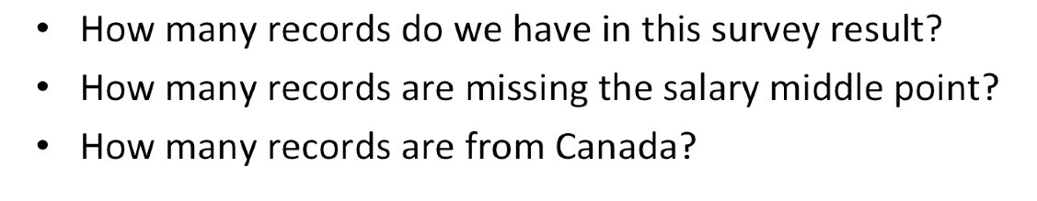

Getting Started:

Creating a longAccumulator with sparksContext Driver program.

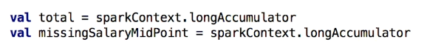

Running accumulator

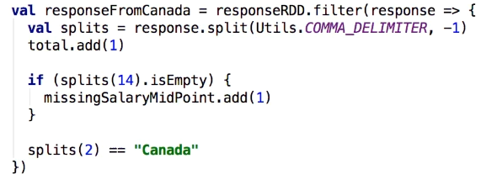

Note: Accumulators are write-only variables

So tasks on worker nodes cannot access the accumulator’s value.

This allows accumulators to be implemented efficiently.without having to communicate every update by worker nodes.

**Alternatives??**

Using reduce. reduceByKey to aggregate values.

**Broadcast Variables**

They allow programmers to keep a read-only variable in each node where data is being processed, as a cache, therefore there is no need of shipping a copy of it with tasks.

All broadcast variables will be kept in all worker nodes.

Usecase:

When all required data is not provided in a single dataset to answer the business problem, and when need to connect two or more datasets together to get desired outputs.

Ex: get registered users’ hometowns, but only postcodes are provided.

Then we need to get another dataset with hometowns against postcodes and need both of them to process.

Step 1:

Load the postcode dataset, broadcast it across the cluster

Step 2: Using map operation, combine them on processing, and get the required results.

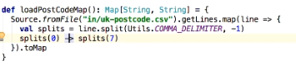



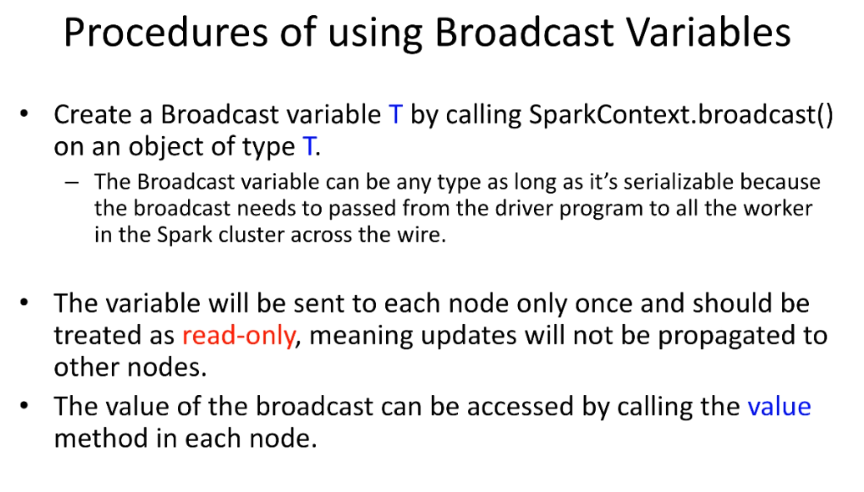

**Spark SQL**

Structured Data:

Has a schema (Known set of fields for each data row)

Benefits of Spark SQL:

Provides dataset abstraction, Dataset is similar to tables in a relational database.

Spark SQL can be treated as a SQL Database

**DataFrame**

* Abstraction, | tabular data
* Introduced since Spark 1.3
* Data is stored inside a Database in a more efficient manner, other than a regular RDD

Its like applying all RDD feature into a schema ( a Relational Database)

* Unlike in RDD, data is organized into **named columns**

Dataset API

* Release since Spark 1.6
* Familiar object-oriented programming style
* Compile-time type safety of the RDD API
* Set of structured data, not necessarily a row, but a particular type.
* Dataset type is known by compile time.

Now (since spark 2.0 DataFrame API has merged to **Dataset API)**

To configure spark SQL, need to add a few dependencies to **build.gradle** file:

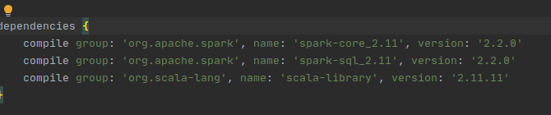

* Not like sparkContext(), to work with sparkSQL we need to create a single-point entry level, therefore we use a session object.



* Spark session follows the Builder Factory design pattern.

Ex: getOrCreate() method : get session object if already created, or create new session.

Session.read will return a DataFrameReader object : Spark interface to load a dataset from extern source.

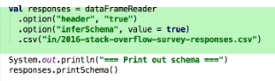

First option says, dataset has a header. So spark will omit the header row.

infoSchema set to true: Schema is automatically created.

.csv(“file”) will input a csv data file. *other formats ex: JSON)

To print the schema:

responses.printSchema();

This will show a description of header (columns)

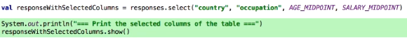

.select() : select set of columns from the dataset.

.show() : show the selected dataset.

.col() : column object (spark concept) : this will **construct a new column** object from a given name of a column.



.==== : compare for equality of a column object

Ex: x.filter (x.col(“colname”) .=== (“value”)) .show()

**groupBy()**

Will return a relational grouped dataset.

Then aggregation can performed on these grouped datasets.

Ex: count()

**Numerical Operations with column objects**



**Sort datasets**

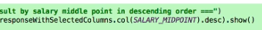

.desc = sort in descending order.

After froupBy() we can aggregate results

Ex:- count(), avg()

**Dividing dataset into groups by a column value**

Ex: put data into groups b salary range:

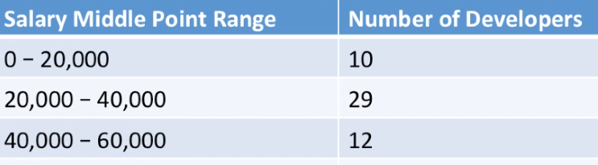



For that col().divide(value).cast(“data_type”).multiply(value)

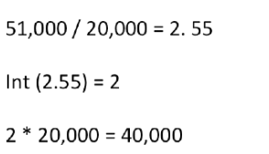

This is done to get rounded values.

**.withColumn(colname, function() )**  -> current data set will include the newColumn including results from executing the function.

**SQL Joins**

**Spark SQL Join was core spark Join**

All spark core join types are supported with sparkSQL joins

In Spak SQL , we don't have the full control of the flow, like in regular RDD joins.

Ex: We don’t have the control on **partitioner**, on datasets

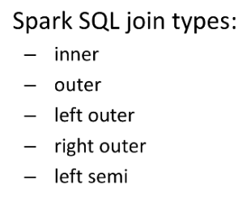

**Spark Lazyness:**

Transactions only keep intents.

Actual computation is processed only an action triggers. And also, it’s done up to required method. (Ex: .first() method)

Sorting in ascending order: (Add **false** as an argument)



**countByValue** : Do both operations done by, map() and reduceByKey() at once for counting operations.

Spark Logistics  
  
 -Experimental

-Developer API

**Note: Important Resources**

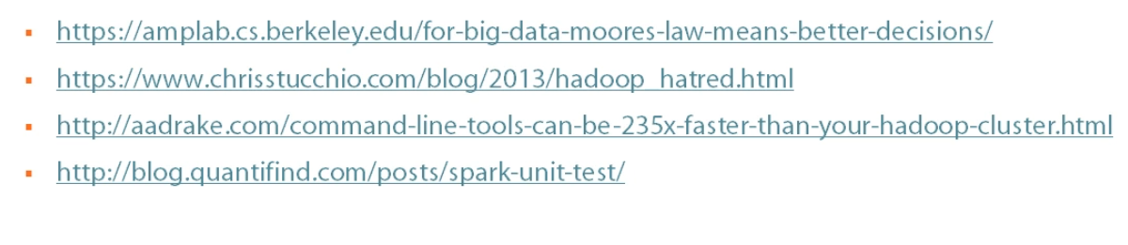

**Spark Core**

Spark Mechanism:

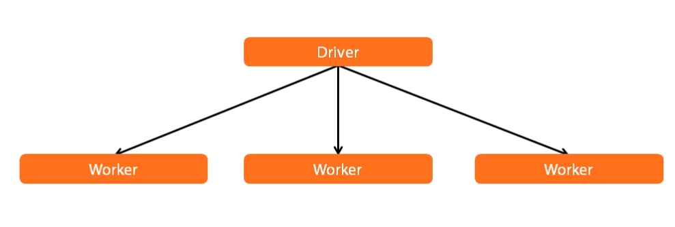

What is Spark Context?

Task Creator

Scheduler

Data Locality

Fault Tolarance

* It allows your Spark Application to access Spark Cluster with the help of Resource Manager (**YARN/Mesos**). To create SparkContext, first **SparkConf** should be made.
* The SparkConf has a configuration parameter that our Spark driver application will pass to SparkContext.
* It allows your Spark Application to access Spark Cluster with the help of Resource Manager (YARN/Mesos).
* To create SparkContext, first SparkConf should be made. The SparkConf has a configuration parameter that our Spark driver application will pass to SparkContext.

**Note: Do not create multiple spark context in same activity**

**(may result in unexpected behavior)**

Ex: Simple word count example:

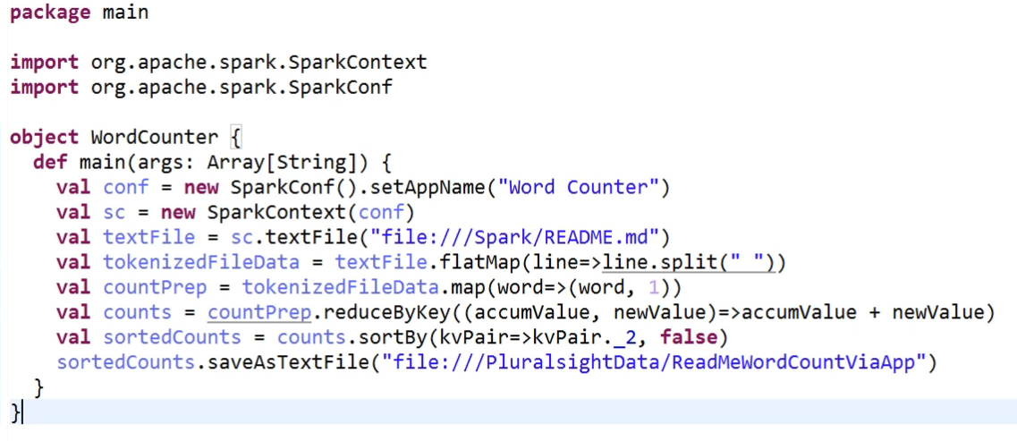

In Spark Java API:

SparkContext ⇒ JavaSparkContext

In non-trivial python file or scala file, Spark app should be run inside man method.

(converting App to main may result in unexpected behavior)

For non-trivial python files:

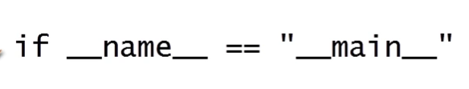

Running a packaged spark application:



***--class : fully qualified name of the scala class which contains sparkContext in main method.***

***--master : name of cluster (here Local[*] local machine)***

***then, path to build jar file***

**Understanding RDD**

Resilient : If a part is failed, it will immediately restart and other parallel processing will continue.

Distributed: work is distributed among nodes in cluster

Dataset: A data collection as usual

**DAG: Directed Asyng Graph :** This creates Sparks Laziness. ( A graph of activities to be performed only when an action is called)

This graph of instructions grows with the given transformations, and executed when an action is called.

Lazy transformations: ex: map, filter etc..

Actions: collect, first, count, reduce

( these will trigger the DAG execution)

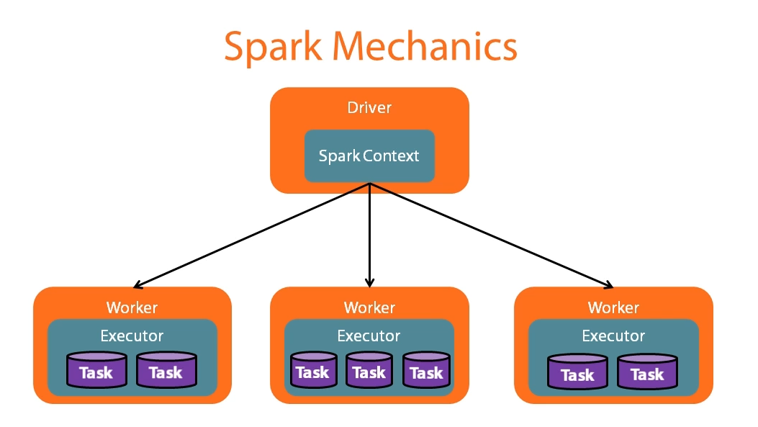

Driver Program → Spark Context → DAG → Action is called → Work distributed among the cluster (nodes, cpu s or both) → Results returned o Driver program → Write to file (optional)

Apache Spark is a framework for real-time data analytics in a distributed computing environment. It executes in-memory computations to increase the speed of data processing. It is faster for processing large-scale data as it exploits in-memory computations and other optimizations. Therefore, it requires high processing power. while Hadoop MapReduce has to read from and write to a disk. As a result, the speed of processing differs significantly – Spark may be up to 100 times faster. However, the volume of data processed also differs: Hadoop MapReduce is able to work with far larger data sets than Spark.

## 

## Tasks Hadoop MapReduce is good for :

* Linear processing of huge data sets.
* Economical solution, if no immediate results are expected

## Tasks Spark is good for:

* Fast data processing
* Iterative processing
* Near real-time processing etc.

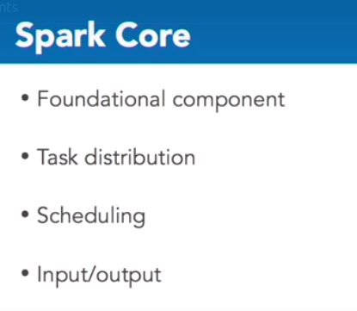

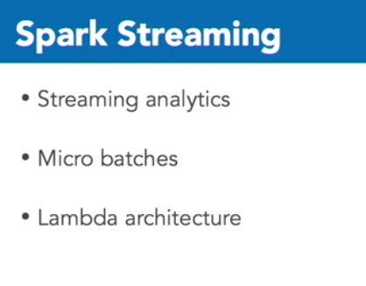

Lambda Architecture:

Updating the streaming aggregation. (without redoing it)

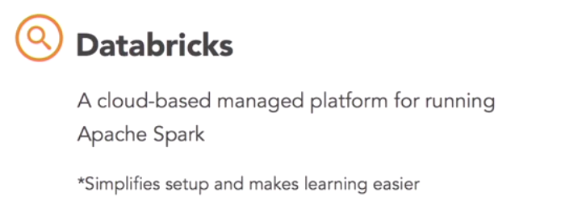

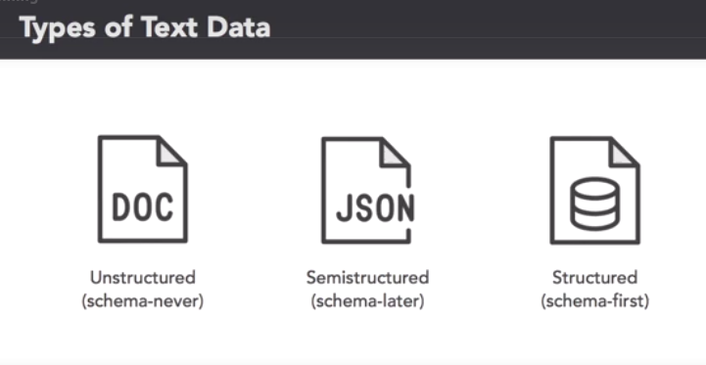

2 ways to load:

**Df = spark.read.csv()**

**Df = spark.read.load( format:’csv’)**

Display a dataframe:

**Display(df)**

Save as a SparkTable:

**df.write.saveAsTable(“out/tb_name”)**

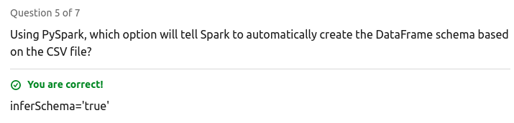

**Spark SQL**

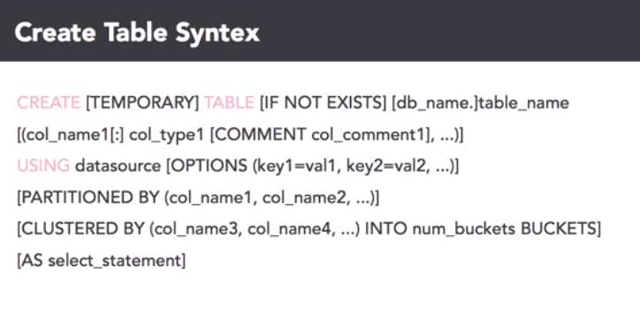

CREATE TABLE IF NOT EXISTS sample_table

( column DataType,

column Datatype )

USING csv OPTIONS

(path = “path_to_csv.csv”)

Data types: string, int, double, etc..

**SQL Joins:**

Ex: **left join** tb_name **on** col1 = col2

**Data Visualization**

Use databrics charts

**Machine Learning in Spark**

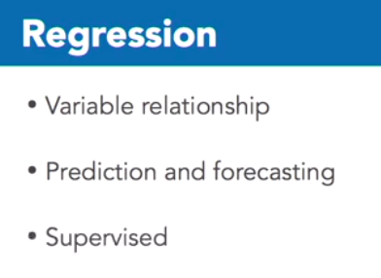

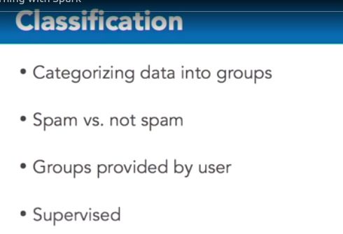

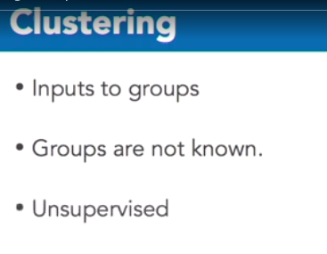

**Cache a dataframe: (operations are faster)**

df.cache()

**Convert SQL table/ text csv to dataframe**

.toDF(“colname”, “colname”)

Before include to ML, format/ pre-process data (ex: remove unnecessary characters in number like commas, dashes etc,,)

**Linear Regression**

Val lr = LinearRegression()

// fitting to models

Val modelA = lr.fit (csvDataFrame, {lr.regParam:0.0})

Val modelB = lr.fit (csvDataFrame, {lr.regParam:100.0})

// get predictions

predictA = modelA.transform(csvDataFrame)

display(predictA) <--- this is also a dataframe

**Evaluation ML mode: ML Evaluation Library**

Ev = RegressionEvaluator()

ev.evaluate(predictA)

***RMSE - Root Mean Squared Error***

**Spark Real-time Processing : Streaming**

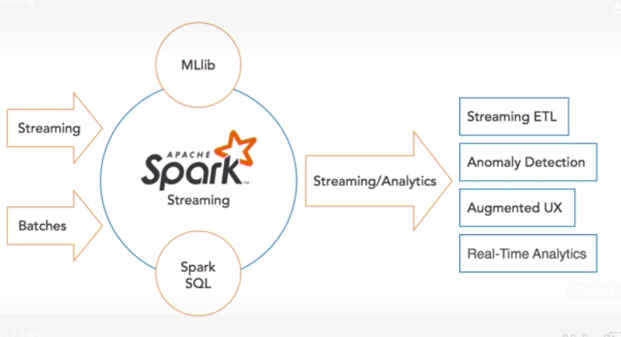

Spark Method: **Micro Batching**

Note: create a zip file

**Curl** “url_for_data” **file** fname.zip

